COME DANCE WITH the
Shutesbury Selectboard at
the
Shutesbury 250th
Anniversary
Moonlight Ball
on the DCR Lake Wyola State Beach
Saturday, September 10, 2011
7pm to midnight
Dancing • Live Music • Food
Formal Attire • Cash Bar - Beer and wine only
Tickets - $12.50 per person
available at Town Hall,
Library, and Shutesbury Market
Or call 413-259-1214
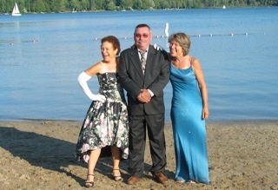
Shutesbury Selectboard, Elaine Puleo, Chair, Albert Springer and April Stein

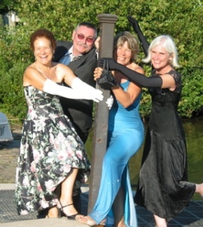

The 250th Anniversary is a special time to celebrate the Shutesbury’s beauty, history, culture, and spirited population. As the summer ends we hope you will join your neighbors and friends to dance on the beach under the full moon. There will be tables and chairs beyond the dance floor to snack and chat with folks that share your streets, woods and lake. There is amble parking at the DCR parking area.

Come out for this historic occasion, a time to put on fancy clothes and enjoy the evening. We are celebrating the past and embracing the challenges of the future.

