LAKE WYOLA ADVISORY COMMITTEE
-Minutes-

July 21, 2018 at 9:00 AM
Shutesbury Town Hall

Members Present: John Gorey, Bob Thompson, Howard Kinder, and Mark Rivers

Guest: Bob Douglas

- New Member

April Stein will be rejoining the committee, representing the Select Board

- Membership renewals

We need to confirm that everyone is still interested in staying on the Committee. The current status is:

Yes | To be Confirmed | No
Catherine Hilton | Richard Brazeau | Paul Lyons
John Gorey
Terry Smith
Mark Rivers
Howard Kinder
Robert Thompson
Walter Tibbetts

Mark will contact Walter and Bob will attempt to contact Rich Brazeau

- The Minutes from the May 19, 2017 meeting were reviewed and approved.

- Road sand/silt runoff problems

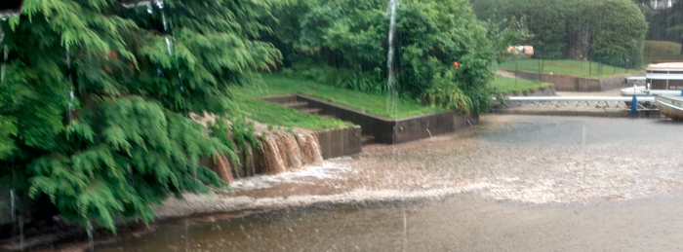

The committee reviewed pictures of severe silt contamination that is flowing into Lake Wyola. The committee’s consensus is that winter road plowing and previous erosion has changed the grading on Great Pines Drive, forcing all of the storm water runoff from Haskins Way and upper Great Pines onto one section of Lake Drive. Also, blocked sections of the Locks Pond Road culvert is causing additional water to be channeled onto Great Pines.

A potential short-term corrective action could be to raise the level of the road and regrading to force water to shed across grassy and wooded areas and prevent it from channelizing down Lake Dr.

The LWA Road committee will need to discuss options including:

- Applying for a 319 grant to obtain funding to implement recommendations that were included in the 2007 Locks Pond Road and Lake Wyola Subwatershed Storm Improvement Study.
- Make an emergency re-grading the intersection of Great Pines and Lake Drives.

The LWAC voted unanimously to support an emergency certification request.

- Update on Lake Wyola cove restoration

All quotes for the engineering design proposals were higher than the available funding. Local residents will be meeting to discuss go-forward options.

- Update on State Park Water Testing

No update at this time.

- Update on Notice of Intent for the Fall drawdown

Mark is starting to work on the Notice of Intent.

- Update on 2016 Lake Wyola Dam Inspection

No update at this time.

- Status of the Locks Pond Culvert

No update at this time. Mark will check with Becky to get an update prior to the August meeting.

- Goose Management – actions for 2018

Mark submitted the 2018 Addling Report to H. Heussman. This year, two nests were located and the eggs oiled. Other nest were not found resulting in a population of 24 geese.

- Update on Boat Ramp Vegetation growth.

Mark will check with Conservation Committee to determine if the vegetation growth that is constricting the boat ramp can be trimmed back.

Next meeting is scheduled for August 18.

