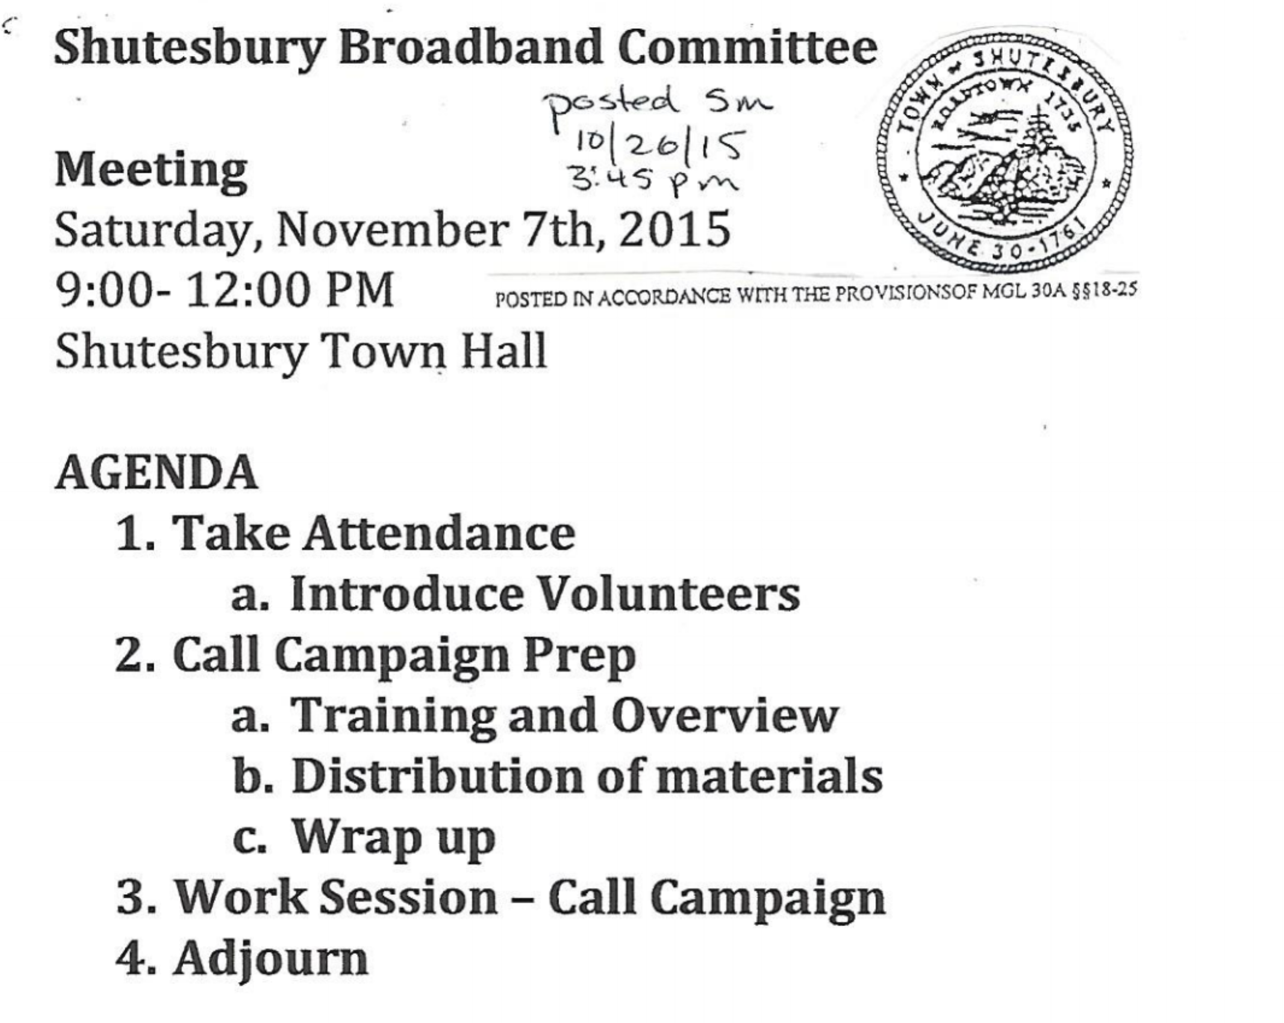
Attendance:
Committee members:
- Asha Strazzero-Wild
- Gayle Huntress
- Craig Martin
- Ayres Hall
Volunteers/ Community members:
- Jim Walton
- Weezie Houle

Notes:
- Gayle went to Montgomery Selectboard meeting; lots of opposition (lost by 2 votes) so need to have help Monday at meeting
- Asha/Gayle going to Montgomery Monday to help with town meeting
- Review of the Coop versus Private plan model document

