COVID-19: ARE WE OVER-REACTING? (NO!)
SOME FAQS

Is COVID-19 really any worse than the flu?

Yes, even though so far, there have been more deaths from the flu, both in the US and worldwide. COVID-19 is very contagious, and the mortality rate, as far as we can see, is much higher, so a lot of people get it, more than would be expected to get the flu. This means more sick people, more hospitalizations, more deaths.

Why do people have to be quarantined for so long?

COVID-19, unlike some other flu-like illnesses, incubates in a new host (you, for example) for 2-14 days, during which time you can infect other people. If you had a known contact with an infected person, or a strong presumption of a known contact, you can be passing it on to others for as long as two weeks before symptoms appear in you.

All this is so disruptive. Wouldn’t it be better to just let the disease come on and get it over with quicker? How bad can it be?

Pretty bad. Based on what’s been observed in other countries, a large number of people are expected to get sick enough to be hospitalized. If they all get sick at once, you have a tremendous surge in hospital admissions. Patients are at risk when hospital staff and equipment can’t meet the need.
This is what “flattening the curve” is all about, as you can see in this illustration from the Centers for Disease Control:

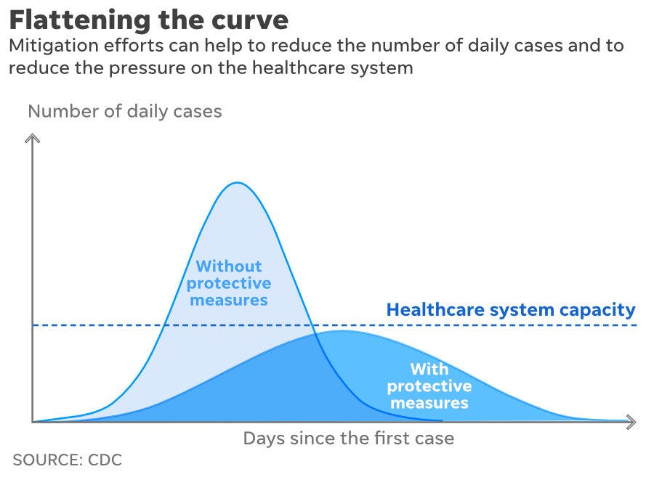

What can I do as an individual to protect myself and others?
(We thought you’d never ask!)

- You already know to stay at home (or keep your child home) if you feel like you’re coming down with something, and to call your health care provider for guidance. Do NOT just go to the doctor or the emergency room; stay home and wait for instructions.

A further tip from Harvard Medical School:
“It's best to not seek medical care in an emergency department unless you have symptoms of severe illness. Severe symptoms include high or very low body temperature, shortness of breath, confusion, or feeling you might pass out. Call the emergency department ahead of time to let the staff know that you are coming, so they can be prepared for your arrival.”

- You also already know to be scrupulous about hygiene. Wash your hands frequently, with soap and water if possible, but if not, with hand sanitizer. In addition, sanitize surfaces that are frequently touched, like doorknobs.

- But here’s a big one, and if you haven’t started doing this, now’s the time to start:
Practice social distancing. This means, in essence, avoiding unnecessary physical contact with others. Say hello and goodbye without a kiss, a hug, or a handshake. Avoid crowds, unnecessary air travel, and –need we say it?—don’t go on any cruises. Keep your distance – six feet from the nearest person is about right. Remember that any of us, you included, could be carryng the disease without knowing it.
Be especially careful around the people who are most at risk: people over 60, especially the very old, or people who have other health problems or compromised immune systems.

If we all take measures to care for ourselves and everyone around us, we’ll weather this crisis as well as we can. So be kind to yourself and others.

The Shutesbury Board of Health

