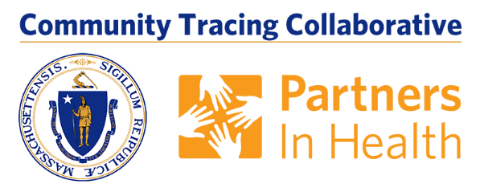

Answer the call and help stop the spread of COVID-19

The MA COVID Team and local boards of health are working together on a contact tracing program to help reduce the spread of COVID-19 in Massachusetts.

Contact tracing in an important tool is reducing the spread of the virus, along with testing and social distancing. Through the Community Tracing Collaborative, everyone who has tested positive will get a call from the Board of Health or the MA COVID Team, making sure they have the support they need to quarantine and get better, and to find out who they have recent been in contact with.

From there, the MA COVID Team or Board of Health will then talk to those contacts, encouraging them to get tested and to stay at home to not spread the virus further. Together with massive testing and hospital care follow up, contact tracing is absolutely essential to stop the virus and get our communities moving again.

What Happens Next? Answer the Call!

- You will receive a phone call from the MA COVID Team. The number
will either be: 833-638-1585 or 857-305-2728. It is important to answer the call.
- During the phone call a Case Investigator will ask you for a list of all the people and places you were within six feet of during the 48 hours prior to your symptoms. For those who do not have symptoms, include all contacts 48 hours prior to your diagnosis. The Case Investigator will also ask for the phone numbers of any people you identify so that they can be reached and notified about their exposure.
- You are encouraged to inform your contacts about your illness, the state will not share your information. The MA COVID Team call your contacts and tell them they have been exposed to COVID-19 so they can get tested, but will not release your name. This process is called contact tracing, and it is a very important piece to fighting this pandemic and stopping transmission.
- We will not share any information with immigration officials or ICE.
- If you are staying at home during the isolation period, the Case Investigator will also discuss any needs you may have for this time period and may connect you with a Care Resource Coordinator who will help you get the support you need.
- A Case Investigator and/or your local board of health will check in on you regularly to monitor your symptoms and needs.

