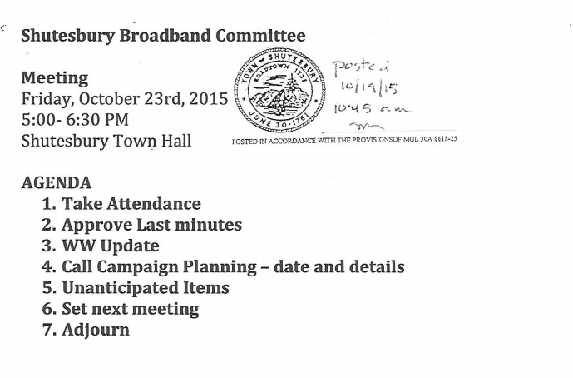Attendees: Asha Strazzero-Wild, Gayle Huntress, Ayres Hall, Eric Stocker, Steve Schmidt, Craig Martin, Guest: Chris Lynch from Matrix
Approve Last Minutes
- Approved last year minutes
- Approved minutes from last two meetings
Call Campaign Planning
- 52.8%
- Need 78 subscribers
  - Members have connected with some residents; a few lost checks, a few people who are going to sign up now
  - Asha to call back folks who have called
- Keep date on Nov 7
- Review the script for the Calling Campaign
  - Script
  - Groups of 10 to folks
Discuss WW Operating Agreement
- Assume Nov 10th is the next Select Board meeting
- 11/6 from 12-2 Info session for Select Boards- discuss WiredWest Operating Plan (Northampton)
  - Steve and Eric will try to go to the agreement workshop
  - Gayle will send a letter to the Select Board letting them know we will review and make a recommendation – Gayle will see if we can get 45 min with Select Board
  - Steve to look into Town Council next steps
WiredWest Update
- MBI is going to hire more than 1 company to do pole surveys
- MBI says design RFP coming
- WW business plan being reviewed by municipal fiber group
- Fibertown Campaign has launched; Shutesbury has declined the post-cards, as we will pursue our own campaign and don’t want to overburden recipients
- 36% of the region has put down $49-
- All towns will have to pay to help with initial build out (weighted contributions)
- Montgomery to re-vote
- Steve to follow up with Becky on the town bonding information
Next meeting Thurs, 11/5 at 6:30 PM
Adjourn

