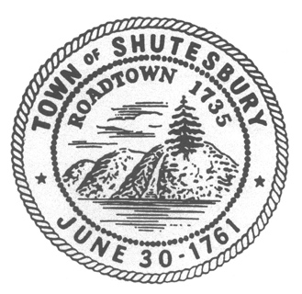
Shutesbury Conservation Commission
P.O. Box 276
Shutesbury MA 01072

To: Lake Wyola Association Board of Directors (LWA)
George Abdow President

CC: Select Board, LWA Board of Directors, Lake Wyola Advisory Committee (LWAC) Highway Department

RE: Road Conditions Shore and Pine Drive

Date: April 11, 2024

Dear George

The Conservation Commission has received several complaints regarding the road conditions on Shore Drive and Pine Drive. These include:
- Pot holes on Shore Drive that are so large that they make it difficult to drive down the road and have the potential to make it impassible for emergency and fire vehicles to safely pass. This is a safety concern as many of the residents are senior citizens
- Swales/culverts are blocked or diverted causing water to flood the road. On one occasion requiring emergency repairs to keep Shore Drive from flooding, and damage to Pine Drive from uncontrolled and redirected water. (Pine Drive Repair Summary)
- Retention Basin is also filled with leaves and road run off, causing the water and sediment to run directly into Lake Wyola.

The Conservation Commission made a site visit on March 21, 2024, and observed all of the same concerns, including areas where the road has been eroded down to the rock layer and the area around the beach is eroding causing water, beach sand and sediment to directly flow into Lake Wyola

These issues have been brought to your attention on October 13, 2024, with a letter documenting the same complaints/issues. Since that time the Commission has received no documentation that any of these issues have been addressed or resolved.

Repairs and resolution of maintenance issues need to be addressed immediately, and documentation provided to the Conservation Commission by May 15, 2024.

In addition, Conditions for Determination of Applicability filed by LWA for work on Shore Drive and Pine Drive in 2019 state:

- # 5 Settling areas will be cleaned at least annually and all material removed from the buffer zone.

To date no documentation has been provided to the Conservation Commission that this work has been done. This would mean LWA is in non-compliance with the Order of Conditions.

This issue must be brought into compliance and documentation provided to the Conservation Commission by May 15, 2024.

All these issues present a concern with silt and sediment flowing into Lake Wyola in violation of the Shutesbury Wetlands Bylaws, and concerns for safety of residents, as water overflows swales and culverts. The Conservation Commission require the following from the LWA who own and are responsible for road conditions, repairs, and maintenance:

- maintenance to fix and prevent growing damage from water causing pot holes and drainage into Lake Wyola
- maintenance of swales/culverts
- Cleaning of retention basin on Pine Drive as per order of conditions
- A plan for ongoing maintenance and repairs to be presented to the Conservation Commission within 60 days.

Sincerely,
Shutesbury Conservation Commission

